The Battle of Neighborhoods

- Introduction/Business Problem
In this 21st Century there is a surge in Indians travelling abroad for education or employment. Studies reveal that students prefer to settle down in the US, the UK, Australia and Canada the most. It comes as no surprise that 1 in every 5 international students is from India. Canada is one the most popular destination for Indian migrants worldwide. Usually people tend to explore the places before moving to a new country, state, city or place for their work or to start a new life that involves so many factors including neighborhood analysis.
Now, Data Science plays a key role in analyzing each neighborhood in a city and gives insights about each and every neighborhood. Analyzing a neighborhood would be helpful for those who are travelling to a new country and get familiarized about their neighborhood even before landing.
The Project takes this requirement as its main idea to help the stakeholders to achieve the desired results, so as to help them spend their time and money in some other productive means rather keep them trapped in an infinite loop of extensive search engine.
My Objective is to provide insights about neighborhoods which have Indian Community in Canada living in Toronto, Ontario regions. These communities with other facilities and access to local establishments like Indian Restaurants, Indian shops, Indian shopping mall, Indian Grocery Market, etc. This helps in analyzing the densely populated neighborhood and predict the top choices for any new immigrant to settle down. This analysis would help the stakeholders take an informed decision before re-locating and picking the top sites that meet their evaluation criteria.
While this specific project has been designed targeting Families & Student communities, the same could be expanded to help Retail Establishments understand the population segmentation and plan for new sites and stores to target these consumers. Additionally the Government and local municipal bodies also are keen to provide the best services and ensure safety in these neighborhood’s, this project also enables them understand the patterns of immigration settlement and scope for new development around this region. The limited availability of data sets has restricted the focus of this assignment to only the end Consumer i.e. Families and Students at this time.
- Approach
K-means clustering unsupervised machine learning model is applied to identify the Indian Community in the Neighborhoods of Toronto, Canada with the help of Foursquare location data and intelligence.
My Approach to Identify the Indian Community in Toronto:
Taking Toronto, Canada as an example, the details of all its neighborhood and their Zip/Postal code are extracted and they are matched with geographical coordinates of the center of each neighborhood. Then using a combination of location data and machine learning, the neighborhoods are explored and segmented into clusters to get deeper insights of each neighborhood.
- Data Section
This section details the various activities and steps performed to extract and analyze the data required to deliver the recommendations desired from this project.
  - Data Requirements and Data Collection:
For the Toronto neighborhood data, a Wikipedia page exists that has all the information we need to explore and cluster the neighborhoods in Toronto.
https://en.wikipedia.org/wiki/List_of_postal_codes_of_Canada:_M
In order to utilize the Foursquare location data, we need to get the latitude and longitude coordinates of each neighborhood which is available as csv file: https://cocl.us/Geospatial_data
  - Data Understanding
This process allows us to check whether the data collected are relevant to solve the problem.
    - Data Preparation
The data obtained from the Wikipedia page has to be transformed into a strucuted format with valid entries.
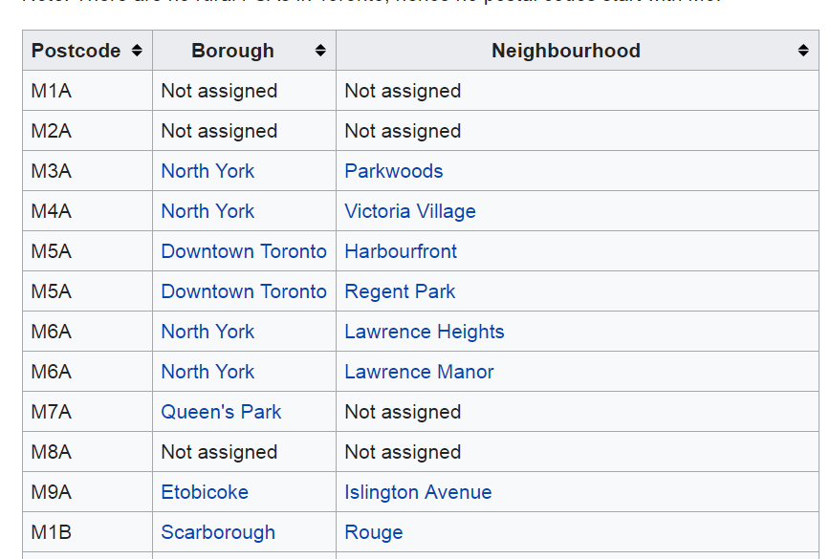

The Following changes are made to construct a Structured Dataset to work with:
- Only process the cells that have an assigned Borough. Ignore cells with a Borough that is Not assigned.
- If a cell has a Borough but a Not assigned Neighborhood, then the Neighborhood will be the same as the Borough.
- More than one Neighborhood can exist in one Postal Code area. For eg. In the above table of Wikipedia page, you will notice that M5A is listed twice and has two Neighborhoods: Harbourfront and Regent Park. These two rows will be combined into one row with Neighborhoods separated with a comma.
- Then the Neighborhood of Canada dataset has to be merged with their latitudes and longitudes.
- Then get the dataset that has Toronto and their Neighborhoods and their coordinates to start the analysis.

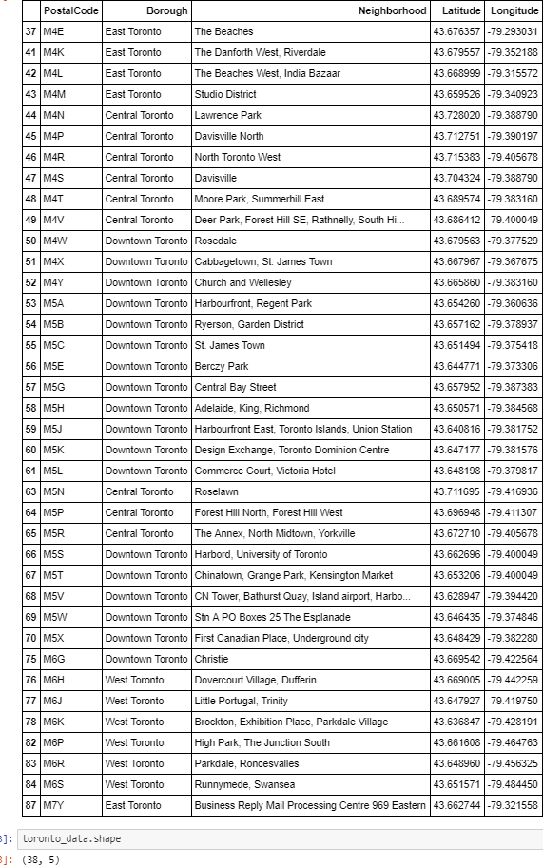
- Methodology Section

  - Explore Neighborhoods in Toronto
The structured format – toronto_data is now used for exploratory data analyses. This is ow visualized in the map of Toronto with the different Neighborhood plotted and highlighted below.
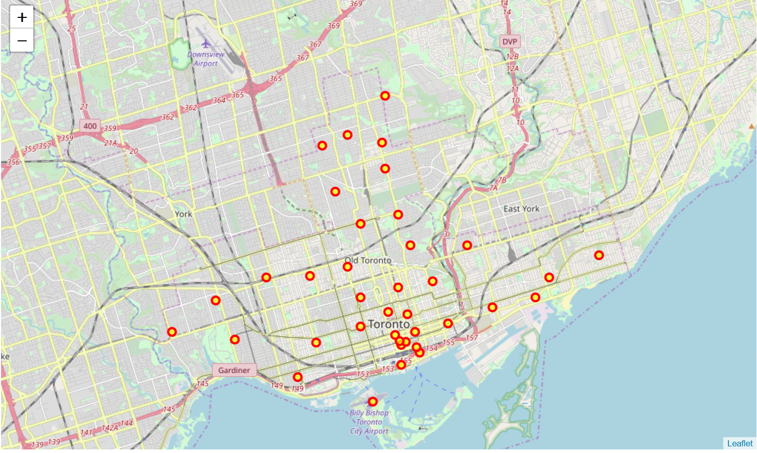
Foursquare location data and Intelligence provides the data categorized by different entities relevant for this project. The data is available across different aspects such as (a) Indian Neighborhoods, (b) Indian Restaurants, (c) Indian shops, (d) Indian markets etc., across all the top neighborhoods of Toronto.
A search query for “Indian” in 1000km radius was applied with the help of Foursquare API calls to all the neighborhoods identified.
The resulting dataset revealed the Names, Categories and their corresponding coordinates of Indian neighborhoods, Indian Restaurants, Park, Indian tattoo Parlor, Indian Astrologer, Indian Consulate/Embassy, Indian Affairs etc., in all the given Neighborhoods of Toronto.
The table below is the snapshot of the data summarized from this query.
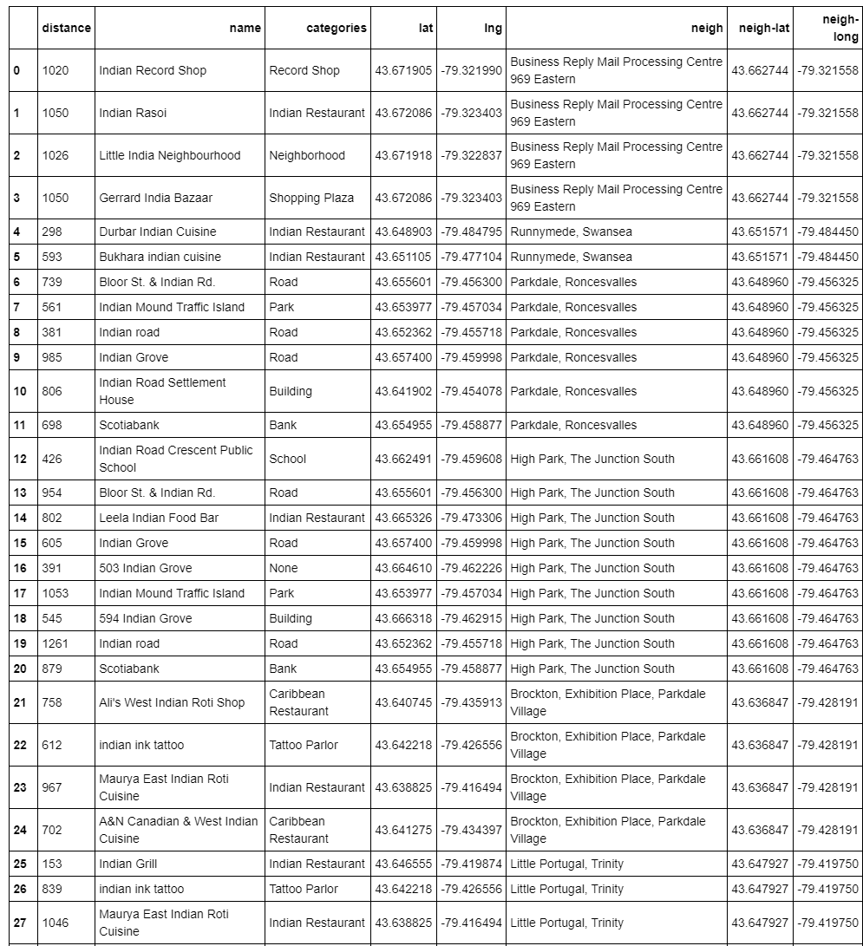
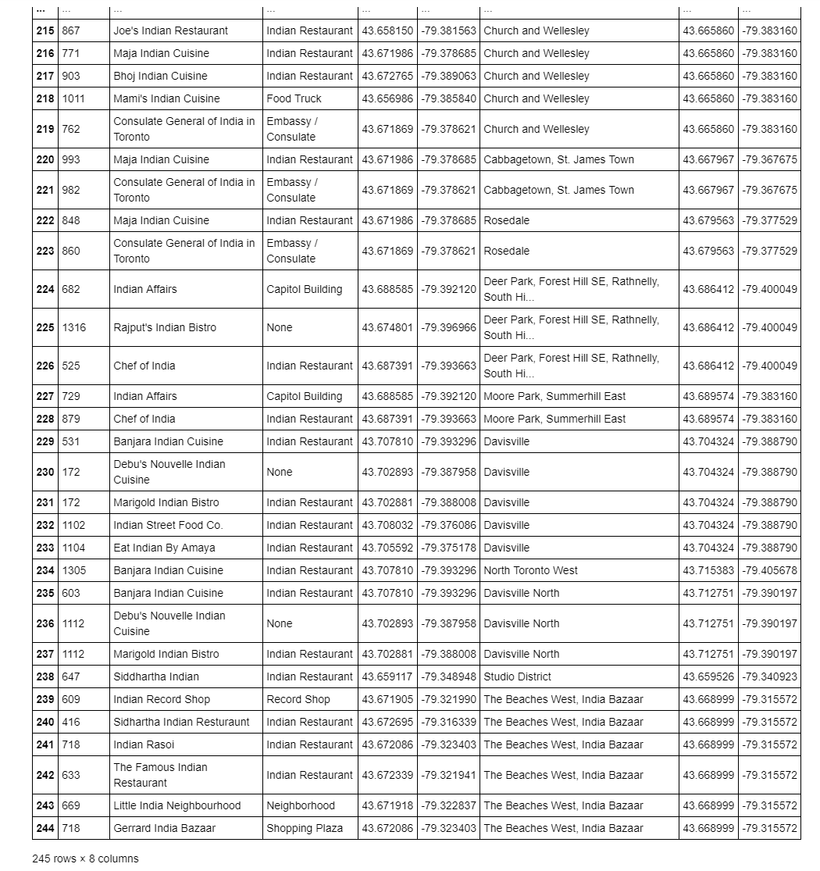
It is observed that only East Toronto and Downtown Toronto has Indian Neighborhoods.
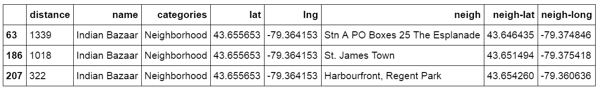

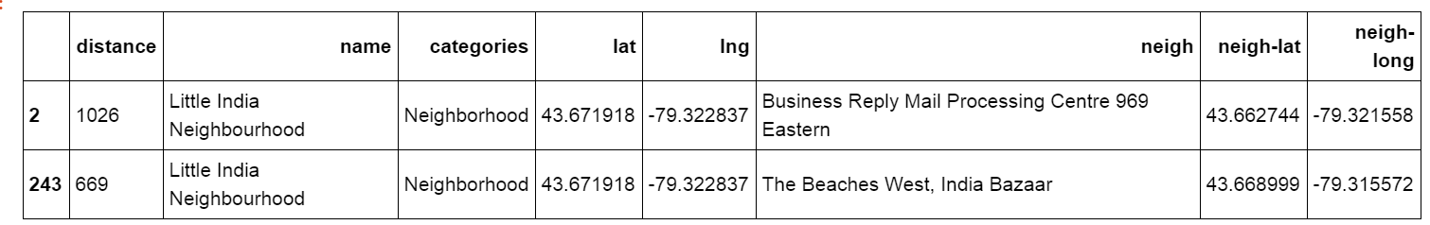

  - Analyze Each Neighborhood
Analysis is done on the given exploratory data and thus revealed the Top 10 Venues for each Neighborhood in Toronto.
The below table shows top 10 locations /communities.
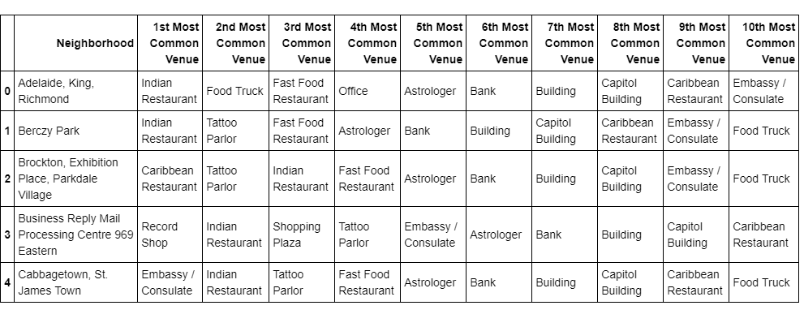
  - Cluster Neighborhoods
A clustering task consists of creating groups of objects that have high intraclass similarity and low interclass similarity. In other words, objects are similar to other objects in the same cluster, but dissimilar to objects in other clusters,
The Unsupervised Machine Learning Model for clustering used for this project is Kmeans Clustering,
Using K-means the neighborhoods are clustered into 5 Clusters. Let’s visualize the clusters.

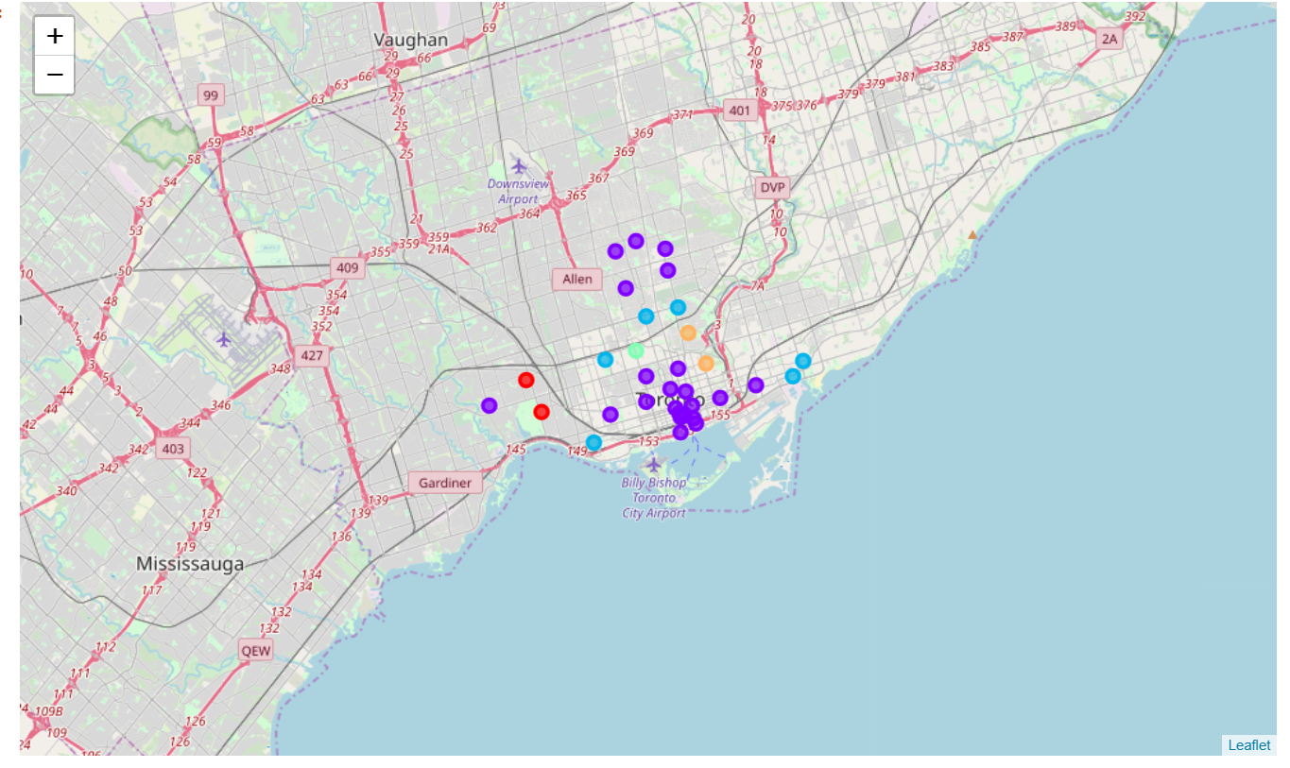
Cluster_0 - Red Cluster_2 - cyan
Cluster_1 - purple Cluster_3 – light green Cluster_4 – Orange

- Results Section

There are 22 neighborhoods in Cluster_1. It is observed that the Indian Neighborhoods: Indian Bazaar in Esplanade, St. James Town, Harbourfront, Regent Park are found in Cluster_1. This is tabulataed below.

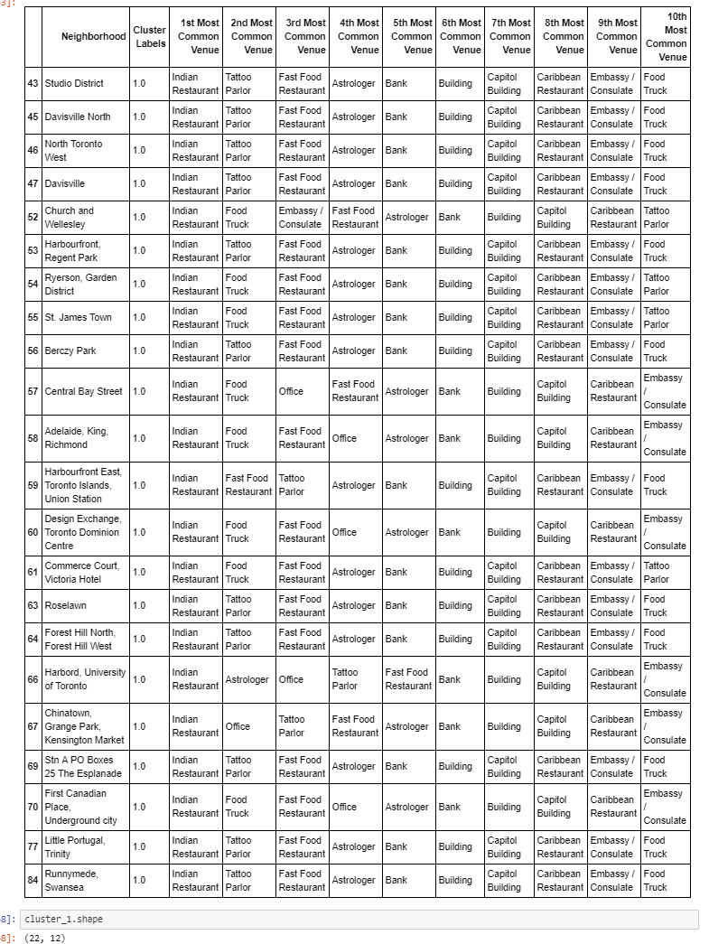

- There are 6 Neighborhoods in Cluster_2. Bank, Astrologer, Shopping Plaza, Capitol Building, Indian Restaurant etc, are the most common venues. Also observed that the Indian Neighborhood - Little India Neighborhood in the Beaches West, India Bazaar, Business Reply Mail Processing Centre 969 Eastern are in Cluster_2. They are tabulated below.
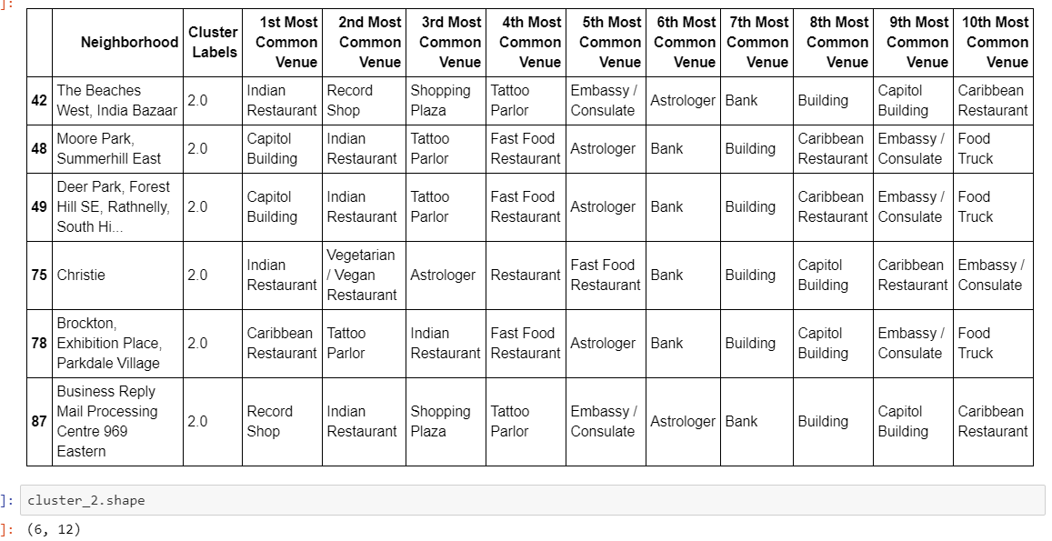

- Discussion Section
6.1 Which is the best locality to settle down?
- Evaluate Criteria for Selecting the community to re-locate to
- Compare localities based on priorities and preferences
- Review results to take “informed decisions”
6.2 Is this the right location to invest for a new restaurant or community center?
- Retail & Business- Understand potential growth opportunities
- Review trend of community expansion & settlement diversity
- Prioritize locations to set up new commercial establishments

6.3 Which Neighborhood’s are popular by ethinicity, demand for new development initiatives?
- Government & Municipal authorities – Town & Community planning
- Predict growth and improve services
- Proactively plan for newer zones development

- Conclusion

St.James Town, Harbourfront, Regent Park, The Esplanade are the top rated neighborhood inToronto where most Indians live. With help of Kmeans analysis, it is observed that they are grouped in Cluster_1 where other amenities like Indian Restaurants, Fast food Restaurant, Food Truck, Tattoo Parlor, and Corporate offices like Bank, Embassy, Capitol Buildings, Astrologer are well established for a comfortable stay in Toronto.

Less densely populated Indian communities are Business Reply Mail Processing Centre 969 Eastern, The Beaches West, Indian Bazaar. They are grouped under Cluster_2 where other amenities like Indian Restaurant, Record Shop, Shopping Plaza, Tattoo Parlor, Embassy / Consulate Office, Astrologer, Bank and Capitol Buildings are available.

